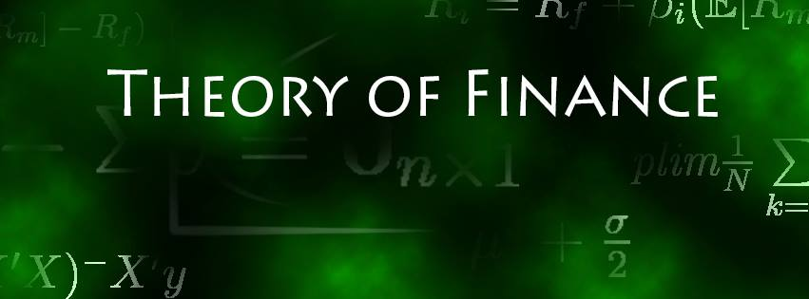

Solution Sheet on Problem Set 4

**Fixed Income**

Deadline: 16.12.2021

**Solved by: ____________________________________________________________**

|  |  |  |
| --- | --- | --- |
| **Task** |  | **Points Earned** |
| **Forwards to Interest**  a)  Different types of interest rates  (9 points) |  |  |
| b)  Z-Bond prices  (7 points) |  |  |
| c)  Forward Rate (3y to 20y) (4 points) |  |  |
| **Fix.Inc. Calculus**  a)  Coupon bond price (4 points) |  |  |
| b) Yield-to-maturity  (4 points) |  |  |
| c) Bond Duration’s  (6 points) |  |  |
| d) Scenarios: description (6 points) |  |  |
| e) Scenarios: YTM (10 points) |  |  |
| f) Scenarios: prices (10 points) |  |  |
| **3.**  **Yield Curve** a) Yield curve patterns (4 points) | **Yield Curve:**    From the yield curve, we can observe that the interest rates on government bonds for the maturities of one and three years break the theoretical concave structure. For this to hold, we would assume higher interest rates for these maturities and hence absolute increasing but marginally decreasing interest rates. Furthermore, due to the inflation-targeting low interest rate policy, i.e. in Europe and in the US, the yield curve is fully defined at negative interest rates for maturities up to 20 years. Lastly, for the short maturities of 1m, 2m and 3m, we would also assume slightly increasing interest rates, whereby equal rates are observed in the data. |  |
| b)  Z-bond prices (6 points) | **Zero Coupon Bond Term Structure:** |  |
| c) Yield curve fit (8 points) |  |  |
| d) 7 year z-bond (5 points) |  |  |
| e) Semi-annual coupon bond (5 points) |  |  |
| f) Level, slope & curvature (6 points) |  |  |
| g) Different Spreads (6 points) |  |  |